**Where to Set-Up Shop in Los Angeles?**

**Joseph Kenrick**

**January 5, 2020**

**Introduction**

In this project we will try to find an optimal location for a restaurant and cafe. Specifically, this report will be targeted to stakeholders interested in opening a **Mexican restaurant** and a **Coffee Shop** in **Los Angeles, California**.

In this lab, we will convert addresses into their equivalent latitude and longitude values. Also, we will use the Foursquare API to explore neighborhoods in Los Angeles. We will use the explore function to get the most common venue categories in each neighborhood, and then use this feature to group the neighborhoods into clusters. We will use the *k*-means clustering algorithm to complete this task. We will use the Folium library to visualize the neighborhoods in Los Angeles and their emerging clusters. Finally, we will decide which neighborhood would be an ideal place to open up a Mexican Restaurant, and which neighborhood to open a Coffee Shop.

Utilizing location and feature data to determine the ideal location for a new shop is beneficial for the shop owner to ensure they place their shop in the correct market. An ill-placed shop could mean inadequate customer base and revenue streams, causing the shop to go out of business.

## Data

The data required for this project will come from two sources. The Neighborhoods in LA proper will come from zipdatamaps.com. Then using arcgis geocoder we will get the coordinates of the centers of each of these neighborhoods. This will label and provide the location of each neighborhood. The venue and shop data will come from foursquare. With the neighborhood location data, we can find the top and most common venues in each neighborhood and consequently label each neighborhood accordingly.

Based on definition of our problem, factors that will influence our decision are:

* number of existing restaurants in the neighborhood (any type of restaurant)
* number of and distance to Mexican restaurants or Coffee Shops in the neighborhood, if any
* distance of neighborhood from city center

Link for Neighborhood data:

<https://www.zipdatamaps.com/list-of-zip-codes-in-california.php>

## Methodology

In this project we will direct our efforts on detecting areas of Los Angeles that have high restaurant density, particularly those with high numbers of Mexican Restaurants and Coffee shops. In addition, we will favor clusters with locations closer to the City Center (higher density areas). These clusters and neighborhoods will indicate areas of success with high traffic for Mexican restaurants and Coffee shops, and thus is the location we will decide to set up shop.

In step one, we have collected the required data: location of every neighborhood and its distance from the city center in LA.

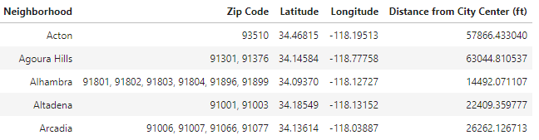

The second step was to identify the top venues in each of these neighborhoods within a 2000m radius.

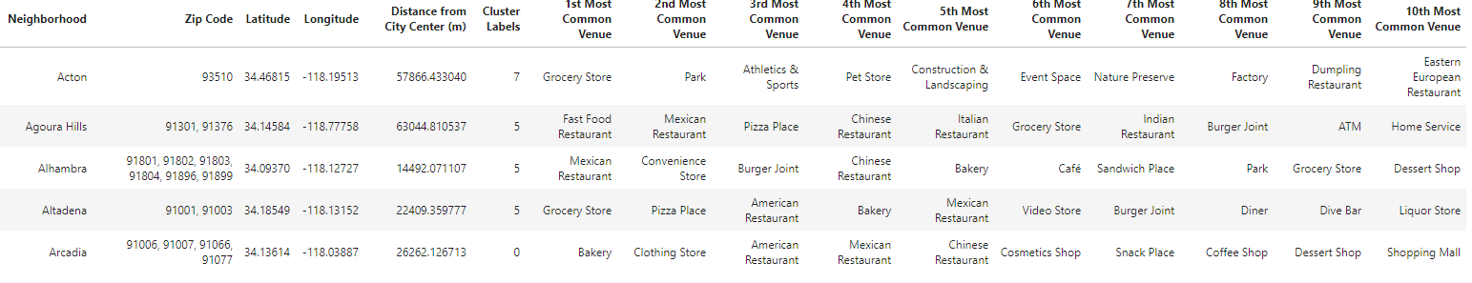

The next step was to group each neighborhood into like clusters based on their top 10 venues via k-means clustering. We created 10 different clusters across LA. Next, we analyzed each cluster individually in order to determine and label the type of area each cluster was and how far on average each cluster is from the city center.

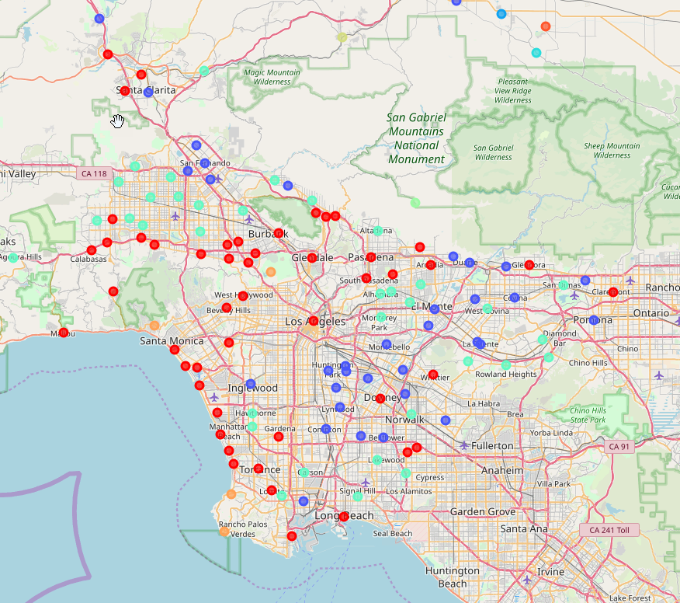

With this analysis we can make an informed decision on where to set up shop in Los Angeles.

## Analysis

The results from the k-means clustering show that we can focus cluster 0 and 2 for the result of our analysis:

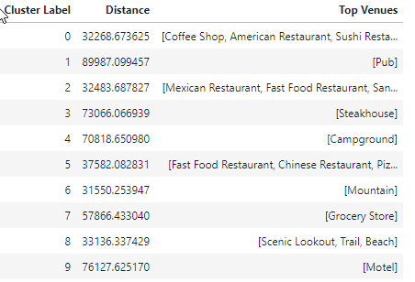

Looking at just Cluster 0 data, then filtering by neighborhoods with the most common stop being a Coffee shop, and finally sorting by distance to city center we get the following results:

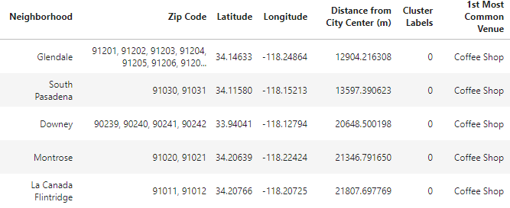

The same was done with Cluster 2 and Mexican Restaurants.

## Results and Discussion

Our analysis of k-means clustering clearly showed which clusters were favorable to set up shop for a Mexican Restaurant and which to set up a Coffee shop. Within the Coffee shop cluster, there were 13 neighborhoods where a Coffee shop was the most common venue, and within the Mexican Restaurant cluster, there were 20 neighborhoods where a Mexican Restaurant was the most common venue.

There are neighborhoods with high concentrations of Mexican Restaurants and Coffee Shops all over Los Angeles County, but by considering distance to the Los Angeles City center, and thus the high tourist areas with ease of public transportation, we were able to find the best neighborhoods for each shop. **Glendale for the Coffee Shop, and Huntington Park for the Mexican Restaurant.**

The two neighborhoods are shown on the map below relative to the city center:

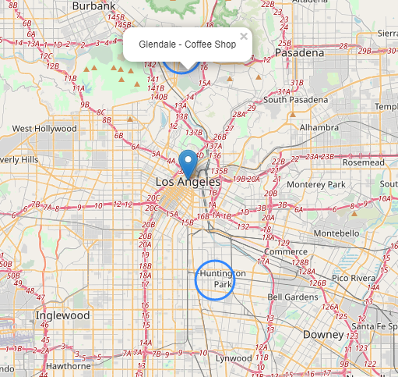

## Conclusion

Purpose of this project was to identify Los Angeles areas close to center with high number of venues (particularly Mexican restaurants and Coffee shops) in order to aid stakeholders in narrowing down the search for optimal location for a new restaurant/shop. Clustering of those locations was then performed in order to create major zones of interest (containing greatest number of potential locations) and then to be used as starting points (Cluster 0 and Cluster 2) for exploration by stakeholders. By clustering neighborhoods by restaurant distribution from Foursquare data we have first identified general boroughs that justify further analysis.

Final decision on optimal restaurant location was based on location to city center to indicate neighborhoods on convenient access and higher traffic.